Coursera - Practical Machine Learning - Quiz2

*Jean-Luc BELLIER*

*13 janvier 2017*

Question 1

Load the Alzheimer’s disease data using the commands:

suppressWarnings(**library**(AppliedPredictiveModeling))

data(AlzheimerDisease)

suppressWarnings(**library**(caret))

## Loading required package: lattice

## Loading required package: ggplot2

Which of the following commands will create non-overlapping training and test sets with about 50% of the observations assigned to each?

adData = data.frame(predictors)

trainIndex = createDataPartition(diagnosis,p=0.5,list=FALSE)

training = adData[trainIndex,]

testing = adData[-trainIndex,]

adData = data.frame(diagnosis,predictors)

trainIndex = createDataPartition(diagnosis,p=0.50)

training = adData[trainIndex,]

testing = adData[-trainIndex,]

adData = data.frame(diagnosis,predictors)

trainIndex = createDataPartition(diagnosis, p = 0.50,list=FALSE)

training = adData[trainIndex,]

testing = adData[-trainIndex,]

adData = data.frame(diagnosis,predictors)

train = createDataPartition(diagnosis, p = 0.50,list=FALSE)

test = createDataPartition(diagnosis, p = 0.50,list=FALSE)

***Answer :*** The ***The correct answer is 3.***. The source dataset needs to contain both *diagnosis* and *predictors*, and the result of CreateDataPartition cannot be a list, otherwise the use in adData produces an error.

Question 2

Load the cement data using the commands:

suppressWarnings(**library**(AppliedPredictiveModeling))

data(concrete)

suppressWarnings(**library**(caret))

set.seed(1000)

inTrain = createDataPartition(mixtures$CompressiveStrength, p = 3/4)[[1]]

training = mixtures[ inTrain,]

testing = mixtures[-inTrain,]

Make a plot of the outcome (CompressiveStrength) versus the index of the samples. Color by each of the variables in the data set (you may find the cut2() function in the Hmisc package useful for turning continuous covariates into factors). What do you notice in these plots?

* There is a non-random pattern in the plot of the outcome versus index that is perfectly explained by the FlyAsh variable.
* There is a non-random pattern in the plot of the outcome versus index that is perfectly explained by the Age variable.
* There is a non-random pattern in the plot of the outcome versus index.
* There is a non-random pattern in the plot of the outcome versus index that does not appear to be perfectly explained by any predictor suggesting a variable may be missing.

suppressWarnings(**library**(Hmisc))

## Loading required package: survival

##

## Attaching package: 'survival'

## The following object is masked from 'package:caret':

##

## cluster

## Loading required package: Formula

##

## Attaching package: 'Hmisc'

## The following objects are masked from 'package:base':

##

## format.pval, round.POSIXt, trunc.POSIXt, units

*# Define vector containing line numbers*

index <- seq_along(1:nrow(training))

*# Number of cut groups*

nbGroups <- 10

*# colour by FlyAsh*

FlyAshCut <- cut2(training$FlyAsh,g=nbGroups)

ggplot(data=training,aes(x=index,y=CompressiveStrength,color=FlyAshCut))+ geom_point()

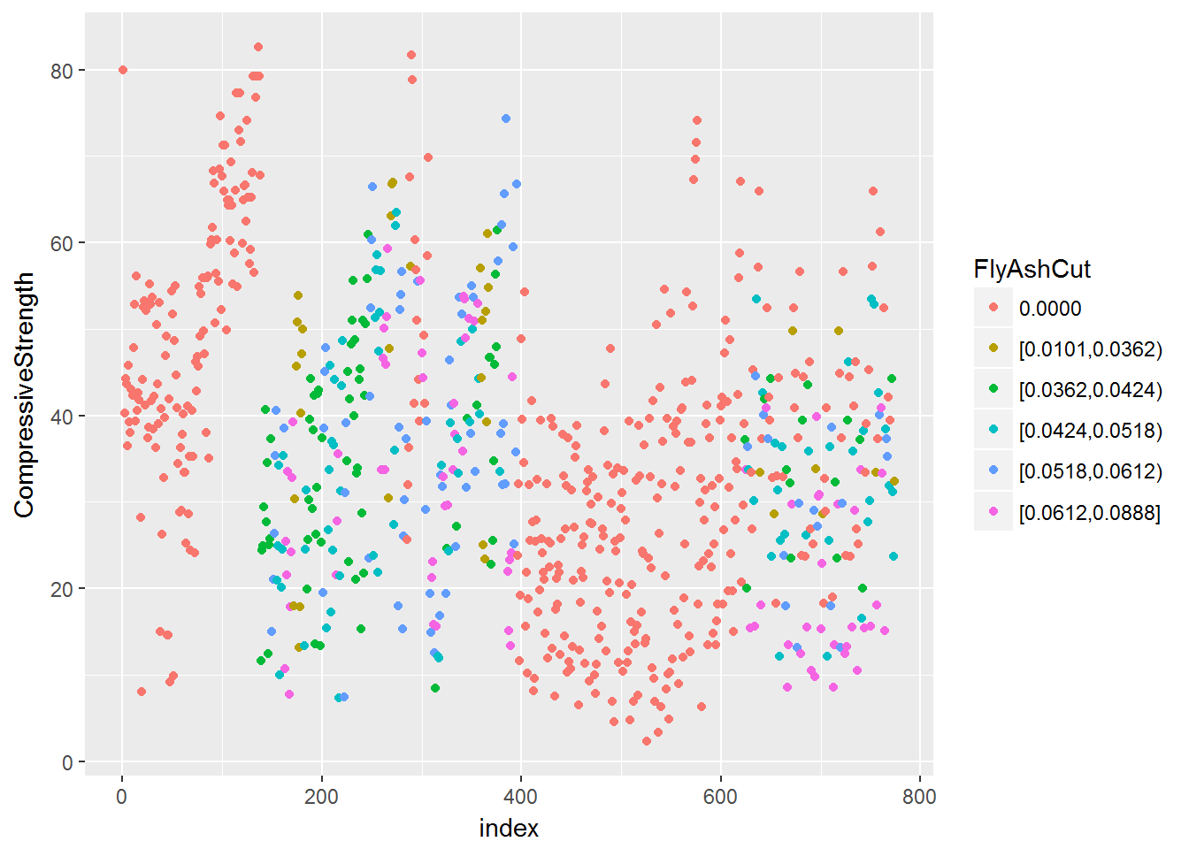

*# colour by Age*

AgeCut <- cut2(training$Age,g=nbGroups)

ggplot(data=training,aes(x=index,y=CompressiveStrength,color=AgeCut))+ geom_point()

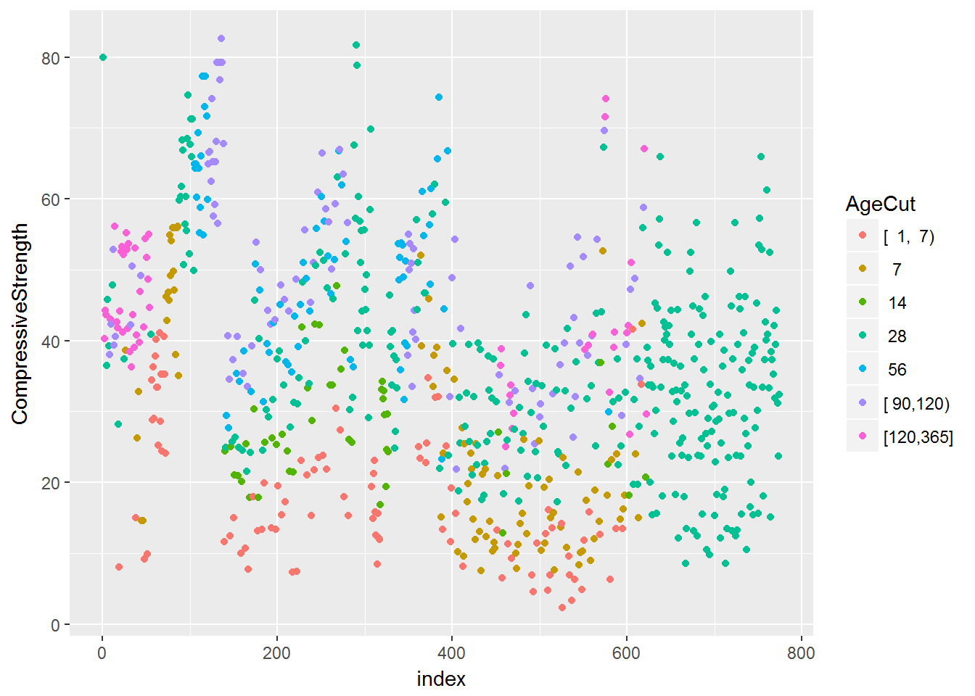

*# colour by Cement*

CementCut <- cut2(training$Age,g=nbGroups)

ggplot(data=training,aes(x=index,y=CompressiveStrength,color=CementCut))+ geom_point()

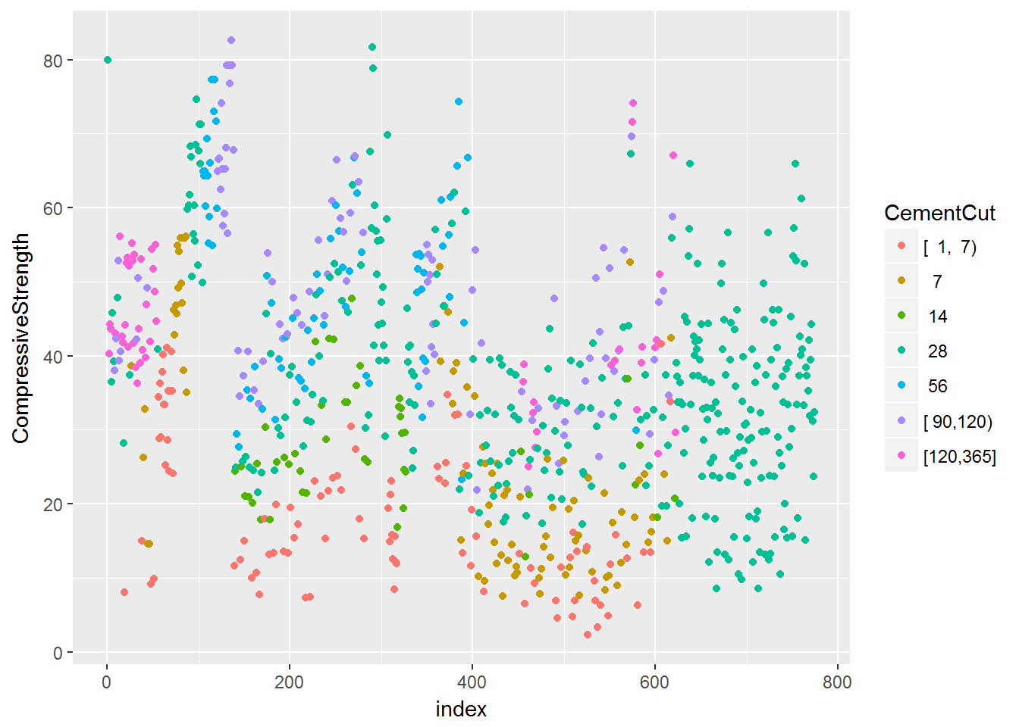

*# colour by Water*

WaterCut <- cut2(training$Age,g=nbGroups)

ggplot(data=training,aes(x=index,y=CompressiveStrength,color=WaterCut))+ geom_point()

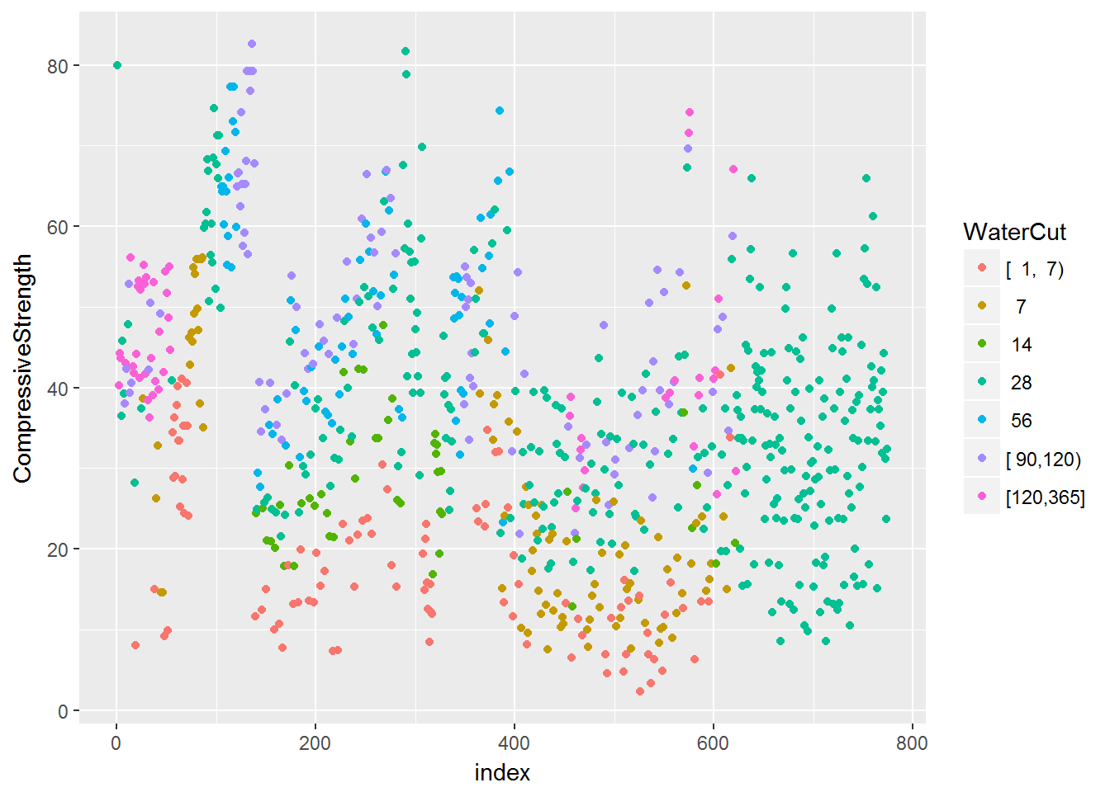

*# colour by BlastFurnaceSlag*

BlastFurnaceSlagCut <- cut2(training$Age,g=nbGroups)

ggplot(data=training,aes(x=index,y=CompressiveStrength,color=BlastFurnaceSlagCut))+ geom_point()

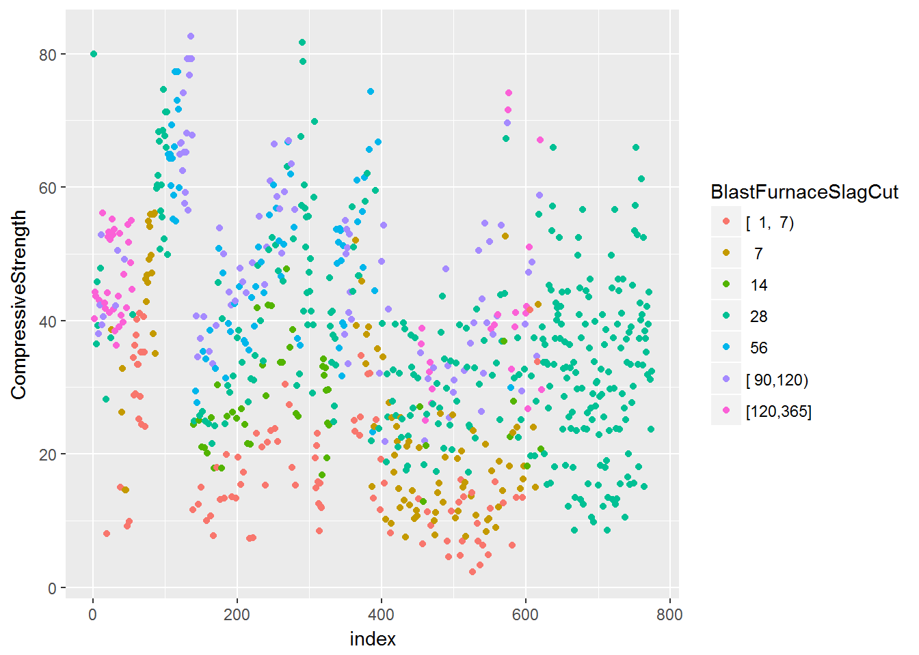

*# colour by BlastFurnaceSlag*

SuperplasticizerCut <- cut2(training$Age,g=nbGroups)

ggplot(data=training,aes(x=index,y=CompressiveStrength,color=SuperplasticizerCut))+ geom_point()

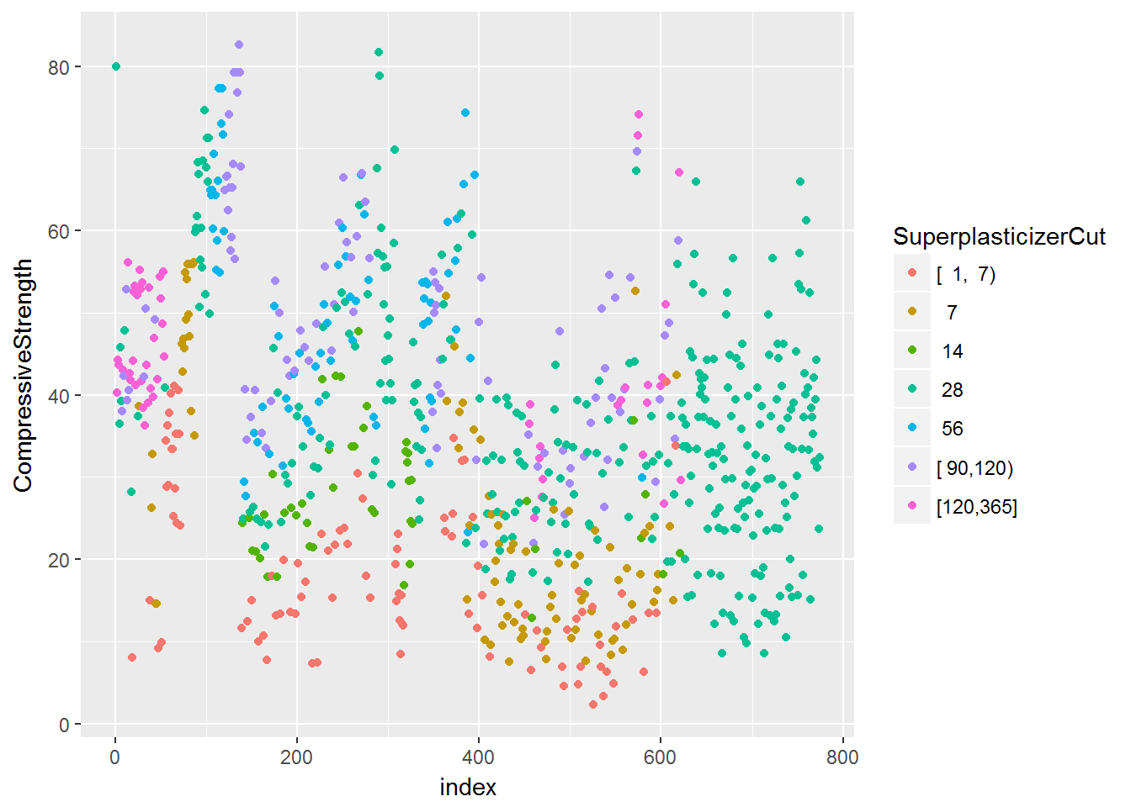

*# colour by CoarseAggregate*

CoarseAggregateCut <- cut2(training$Age,g=nbGroups)

ggplot(data=training,aes(x=index,y=CompressiveStrength,color=CoarseAggregateCut))+ geom_point()

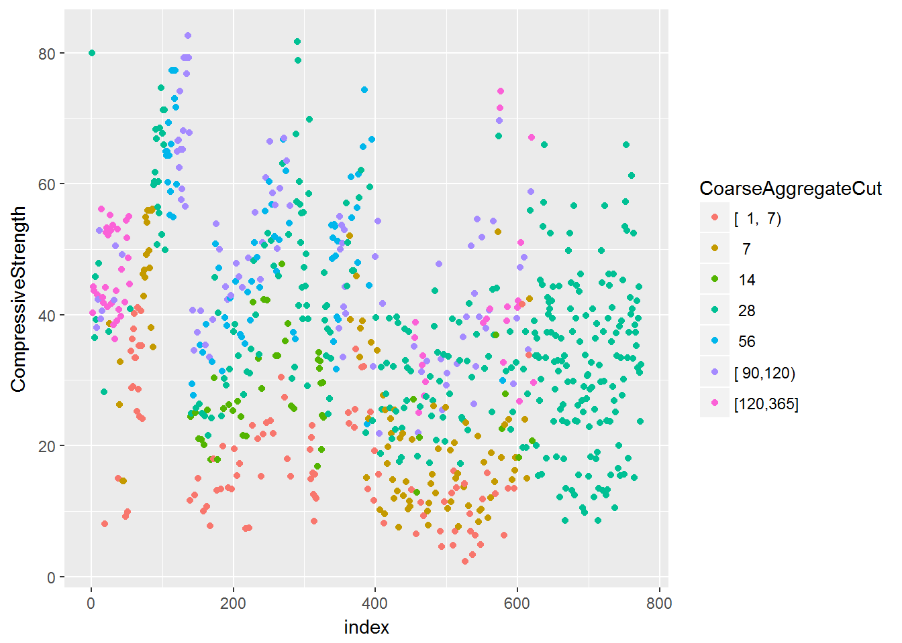

*# colour by FineAggregate*

FineAggregateCut <- cut2(training$Age,g=nbGroups)

ggplot(data=training,aes(x=index,y=CompressiveStrength,color=FineAggregateCut))+ geom_point()

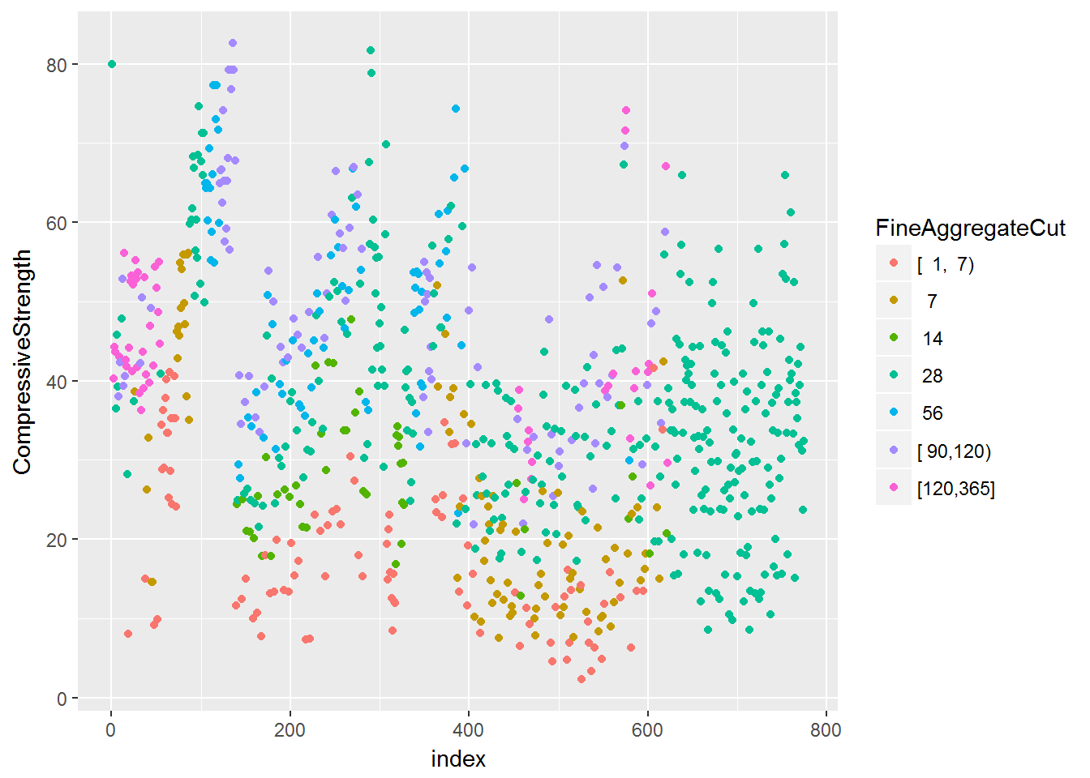

*# colour by FineAggregate*

FineAggregateCut <- cut2(training$Age,g=nbGroups)

ggplot(data=training,aes(x=index,y=CompressiveStrength,color=FineAggregateCut))+ geom_point()



Question 3

Load the cement data using the commands:

suppressWarnings(**library**(AppliedPredictiveModeling))

data(concrete)

suppressWarnings(**library**(caret))

set.seed(1000)

inTrain = createDataPartition(mixtures$CompressiveStrength, p = 3/4)[[1]]

training = mixtures[ inTrain,]

testing = mixtures[-inTrain,]

Make a histogram and confirm the SuperPlasticizer variable is skewed. Normally you might use the log transform to try to make the data more symmetric. Why would that be a poor choice for this variable?

* There are values of zero so when you take the log() transform those values will be -Inf.
* The SuperPlasticizer data include negative values so the log transform can not be performed.
* The log transform does not reduce the skewness of the non-zero values of SuperPlasticizer
* The log transform produces negative values which can not be used by some classifiers.

ggplot(training, aes(x=training$Superplasticizer))+ geom_histogram(color="black",fill="lightblue") + labs(title="Histogram of Superplasticizer",

x ="Superplasticizer", y = "Count")

## `stat_bin()` using `bins = 30`. Pick better value with `binwidth`.

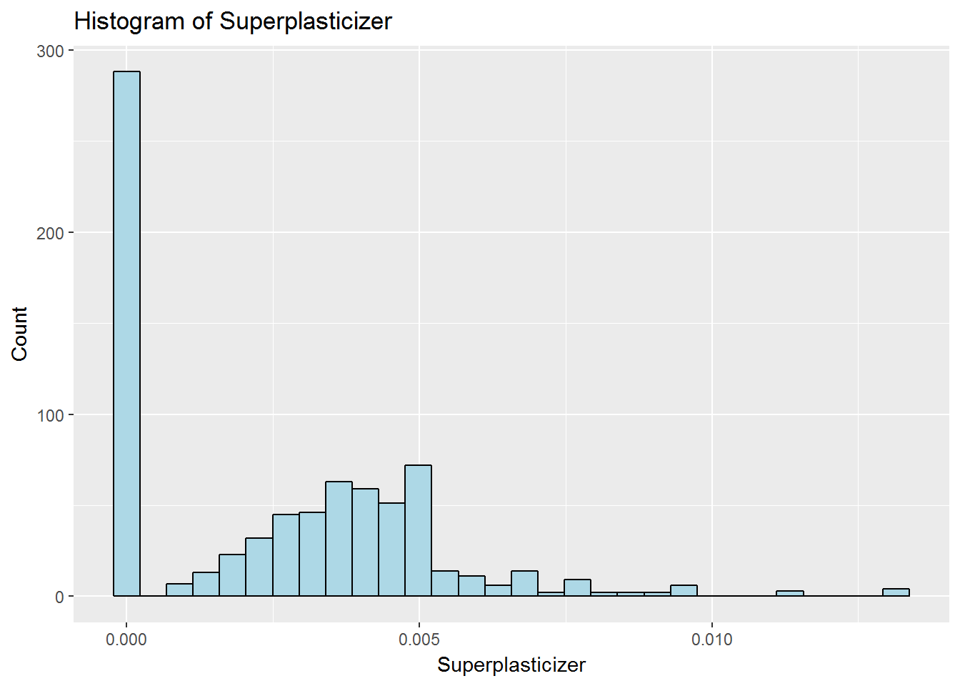

We can notice that some values of Superplasticizer are 0, which is confirmed by calling the summary on *training* dataset. So ***There are values of zero so when you take the log() transform those values will be -Inf***.

Question 4

Load the Alzheimer’s disease data using the commands:

suppressWarnings(**library**(caret))

suppressWarnings(**library**(AppliedPredictiveModeling))

set.seed(3433)

data(AlzheimerDisease)

adData = data.frame(diagnosis,predictors)

inTrain = createDataPartition(adData$diagnosis, p = 3/4)[[1]]

training = adData[ inTrain,]

testing = adData[-inTrain,]

Find all the predictor variables in the training set that begin with IL. Perform principal components on these variables with the preProcess() function from the caret package. Calculate the number of principal components needed to capture 90% of the variance. How many are there?

* 10
* 8
* 7
* 9

IdxCol_IL <- grep("^IL", names(training))

train_IL <- training[,IdxCol_IL]

test_IL <- testing[,IdxCol_IL]

preproc <- preProcess(train_IL, method="pca", thresh=0.9)

preproc$numComp

## [1] 9

***Anwser :*** ***The number of principal components necesssary to explain 90% of the variance is 9***.

Question 5

Load the Alzheimer’s disease data using the commands:

**library**(caret)

**library**(AppliedPredictiveModeling)

set.seed(3433)

data(AlzheimerDisease)

adData = data.frame(diagnosis,predictors)

inTrain = createDataPartition(adData$diagnosis, p = 3/4)[[1]]

training = adData[ inTrain,]

testing = adData[-inTrain,]

Create a training data set consisting of only the predictors with variable names beginning with IL and the diagnosis. Build two predictive models, one using the predictors as they are and one using PCA with principal components explaining 80% of the variance in the predictors. Use method=“glm” in the train function.

What is the accuracy of each method in the test set? Which is more accurate?

* Non-PCA Accuracy: 0.91  
  PCA Accuracy: 0.93
* Non-PCA Accuracy: 0.72  
  PCA Accuracy: 0.65
* Non-PCA Accuracy: 0.72  
  PCA Accuracy: 0.71
* Non-PCA Accuracy: 0.65  
  PCA Accuracy: 0.72

set.seed(3430)

suppressMessages(**library**(dplyr))

IdxCol_IL <- grep("^IL", names(testing))

names_IL <- names(testing[,IdxCol_IL])

newcols <- c(names_IL,"diagnosis")

new_testing <- testing [,newcols]

new_training <- training[,newcols]

*# Model 1 : predictors as they are, without PCA*

model_without_PCA <- train(diagnosis~., data=new_training, preProcess=c("center","scale"),method="glm")

model_result_without_PCA <- confusionMatrix(new_testing$diagnosis,predict(model_without_PCA,subset(new_testing, select = -c(diagnosis))))

model_result_without_PCA

## Confusion Matrix and Statistics

##

## Reference

## Prediction Impaired Control

## Impaired 2 20

## Control 9 51

##

## Accuracy : 0.6463

## 95% CI : (0.533, 0.7488)

## No Information Rate : 0.8659

## P-Value [Acc > NIR] : 1.00000

##

## Kappa : -0.0702

## Mcnemar's Test P-Value : 0.06332

##

## Sensitivity : 0.18182

## Specificity : 0.71831

## Pos Pred Value : 0.09091

## Neg Pred Value : 0.85000

## Prevalence : 0.13415

## Detection Rate : 0.02439

## Detection Prevalence : 0.26829

## Balanced Accuracy : 0.45006

##

## 'Positive' Class : Impaired

##

*# Model 2 : predictors using PCA, with explanation of 80% of variance*

preProc_pca <- preProcess(subset(new_training, select = -c(diagnosis)), method="pca", thresh=0.8)

trainPC <- predict(preProc_pca,subset(new_training, select = -c(diagnosis)))

testPC <- predict(preProc_pca,subset(new_testing, select = -c(diagnosis)))

*# Syntax to use to avoid "undefined columns selected" error message (by following the formula defined in the slides.)*

model_with_PCA<- train(x = trainPC, y = new_training$diagnosis,method="glm")

model_result_with_PCA <- confusionMatrix(new_testing$diagnosis,predict(model_with_PCA, newdata=testPC))

model_result_with_PCA

## Confusion Matrix and Statistics

##

## Reference

## Prediction Impaired Control

## Impaired 3 19

## Control 4 56

##

## Accuracy : 0.7195

## 95% CI : (0.6094, 0.8132)

## No Information Rate : 0.9146

## P-Value [Acc > NIR] : 1.000000

##

## Kappa : 0.0889

## Mcnemar's Test P-Value : 0.003509

##

## Sensitivity : 0.42857

## Specificity : 0.74667

## Pos Pred Value : 0.13636

## Neg Pred Value : 0.93333

## Prevalence : 0.08537

## Detection Rate : 0.03659

## Detection Prevalence : 0.26829

## Balanced Accuracy : 0.58762

##

## 'Positive' Class : Impaired

##

***Answer :***We can notice that the model using PCA is more accurate (71.95%) than the one using the original predictors (64.63%).

***Non-PCA Accuracy: 0.65; PCA Accuracy: 0.72***.